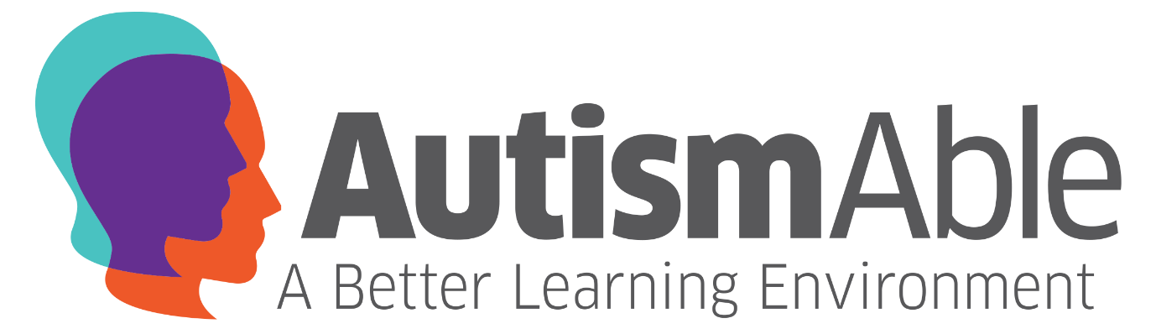
AutismAble CIC are delivering a 10 week Introduction to Singing course commencing:
TUESDAY 6th OCTOBER

VENUE: TBC (Sunderland)

*Eligibility: Adults aged 19+ with Autism or Learning Disability
who reside in Sunderland or Washington

Course Content
- Vocal Exercises and Techniques
- Rhythm
- Introduction to a Range of Instruments
- Breathing Exercises
- Sing Your Favourite Songs
- Christmas Performance (final session)

Session Times Available:
10:00 – 12:00 | 13:00 – 15:00 | 16:00 – 18:00

Each course will run from Tuesday 6th October until Tuesday 15th December. Please note there will be no session on Tuesday 27th October.
To Book Contact: Nichola Laidler
Email: nichola.laidler@autismable.com or Tel: 07833086021

** Funding Eligibility (ESF) – Aged 19+ before 31st August 2015; resident in the UK for past 3 years; Proof of national insurance number required for funding purposes. Minimum of 8 Learners per session.

