LEARNING DISABILITY PARTNERSHIP BOARD

Do you know that Sunderland has a Learning Disability Partnership Board?

The Learning Disability Partnership Board works together with partners to improve the lives of people with a Learning Disability

The Partnership Board would like to hear from people with Learning Disabilities and Family Carers.

We would like to know what your views and experiences are.

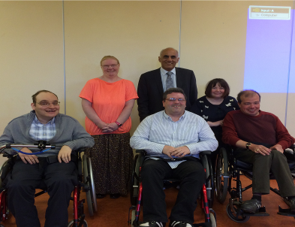

If you would like to get in touch please contact:

Claire Quinn
Partnership Officer
Room 2.2
Civic Centre
Burdon Road
Sunderland
SR2 7DN

TELEPHONE: 0191 561 6148

EMAIL: Claire.quinn@sunderland.gov.uk

