How do we work together to make services better?
Workshop Tuesday 27th October 2015
 | What is this about?  We at Northumberland, Tyne and Wear NHS Foundation Trust want to start involving more people with Learning Disabilities and family members in how services are run.  - To help us work out how we do this, Inclusion North are going to help us run a workshop at:  Thistle County Hotel  (opposite Central Station)  Neville Street,  Newcastle upon Tyne,  NE1 5DF.  The workshop will be from 10.30am – 3pm
What will happen at the workshop?

We will work together and talk about how people are involved now and what should happen in the future
By the end of the workshop we will know
- what works well now
- what is most important to work on next
- what the Trust can do to work more in partnership with people and families

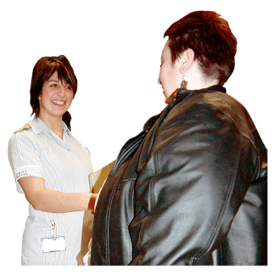 | Who is invited?  People with Learning Disabilities who use the Trust’s services, family members and staff from the Trust are invited to the workshop.
   | Do you want to join us?  Places are limited so please book early  To book your place contact:  Robyn Russell  Telephone: 0191 223 2745  Email: robyn.russell@ntw.nhs.uk  Or for More information contact:  Aileen Boulton on  Telephone: 0191 223 2745  Email aileen.boulton@ntw.nhs.uk

