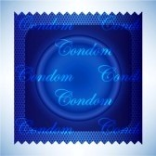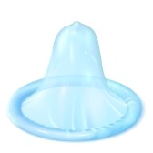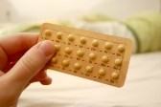

Sexual Health and Personal Relationships Education
For People who have a
Learning Disability

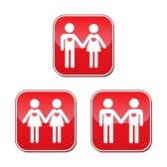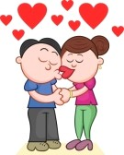

Do you have a learning disability or know someone who has a learning disability who would benefit from receiving sexual health and personal relationships education?

Please call 0303 123 1145
To arrange to speak to our community team about coming to our courses.

Please book on at least two weeks before!
Next course starts 2.30pm 10th November 2015.

