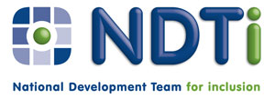

Application form

Finding out about the health and care project
28th April 2016
Skylight 1, The Beacon Westgate Road, Newcastle upon Tyne NE4 9PQ

Please complete a separate application for each person

 | Your Name :
 | Tell us the best way to contact you: | Email
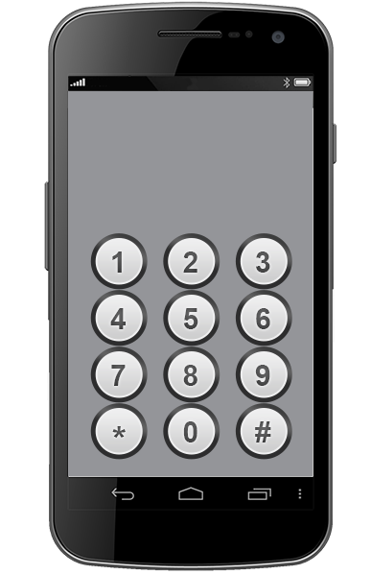 | Tell us the best way to contact you: | Tel:

All information that we give out will be in easy read format.
Please tell us if we need to be aware of any specific needs that you have to help you take part in the training.
These might concern accessibility or mobility requirements, sight/hearing issues, reading/writing or dietary preferences for lunches during the training.

 | Please tell us if you are coming with a supporter | YES / NO

Thank you for your application.

If possible, please send your completed form as an email attachment to events@ndti.org.uk

or send to:

 | National Development Team for Inclusion  First Floor, 30-32 Westgate Buildings, Bath BA1 1EF

 | Tel: 01225 789135

If you send us a completed application form and a place is reserved for you, please let us know if you cannot attend so that we can offer your place to someone else

