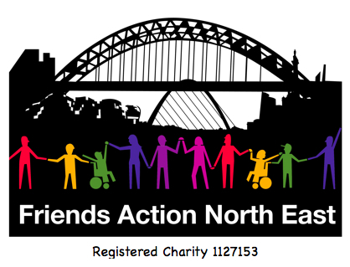
Guest application to a Friends Action North East group’s, events and activities.
Name :  Date: |  | Are you an adult with a learning disability and/or Autism? (Please circle)  Yes No Not sure  What kinds of things do the people who support you, help you to do?
Address :


Age :  Email Address: |  | What are you interested in or what are your hobbies?
Your own Phone Numbers:    Land Line:  Your Mobile:  Emergency phone numbers  1. Name:  Tel:  2. Name:  Tel:  We need two numbers so that we can give them to your Friendship Builder so they have people they could contact if you had any difficulty or an emergency when you were out with them. |  | What support do you have in your life now?  Agency  Family / other Carer  Other – please describe:    Do you have anything you find difficult that you need support with that you think we should know about?  Please describe below:
You have been invited to attend a group or activity by:

Name______________________

I understand that the event or activity I am attending is not supported.

Yes _______ No_________

(some events and activities may have volunteers to guide but not to support)

If I need support to attend the event or activity I will arrange this myself.

Sign_________________

Date:_________________
Do you use a mobile phone?

Yes No

Anything else?
Is there anything else you think we should know to make sure attending the group or activity goes well for you?

What is the best way for us to contact you?


Send me a letter Yes No

Speak to me on the telephone Yes No

Send me an email Yes No

Please return this form to:
Friends Action North East
C/o Ouseburn Farm
Ouseburn Road
Newcastle upon Tyne
NE1 2PA

Tel:0191 231 4327
www.friendsaction.co.uk

