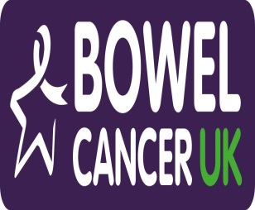

Good bowel health and bowel screening
‘Train the Trainer’

Training health care professionals, families and carers of people with a learning disability to understand good bowel health and screening

Following the success of the initial Good Bowel Health and Bowel Screening course we are offering further ‘Train the Trainer’ courses on;
Thursday, 13th October 2016, Town Hall, Middlesbrough
Friday, 14th October 2016, Waterfront 4, Newcastle
Wednesday, 2nd November 2016, CLDS, Workington
The Train the Trainers course gives individuals the skills and resources to sharing information and deliver a three hour training course to colleagues, carers and families within their locality. Passing on the information to support people with a learning disability to have good bowel health and equal access to the bowel cancer screening programmes (Bowel Scope screening and Faecal Occult Blood test screening).
The Train the Trainers course is delivered over one day and includes all the skills and materials needed to deliver training. This includes all activities, support materials and power point presentation.
If you would like to book a place on the training please send your name, job title, organisation and contact details to Julie.tucker11@nhs.net
If you have any questions contact Julie Tucker on Julie.tucker11@nhs.net or tel: 01138249693 mob: 0786 0177 981.

