**There is one acute hospital in Sunderland:**



Kayll Road

Sunderland SR4 7TP

Phone: 0191 565 6256

Website: www.stsft.nhs.uk

This hospital has a general

Emergency Department.

**Sunderland Royal Hospital**

**There is one specialist hospital for eye problems:**

**Sunderland Eye Infirmary**



Harton Lane,

South Shields,  
 Tyne and Wear  
 NE34 0PL.

Website: www.stsft.nhs.uk

**Tel:** 0191 404 1000

This hospital has a general

Emergency Department.

Queen Alexandra Road

Sunderland SR2 9HP

Phone: 0191 565 6256

Website: www.chsft.nhs.uk

This hospital has an Emergency

Department for accidents or

emergencies relating to eyes

only.

**There is one acute hospital in South Tyneside:**

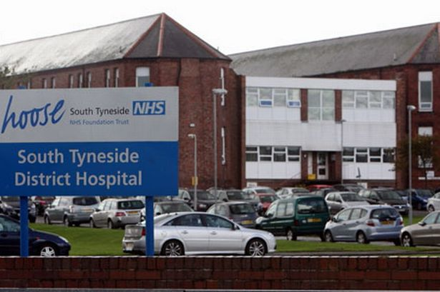**South Tyneside General Hospital**