Practice headed paper

Dear Click here to enter text.
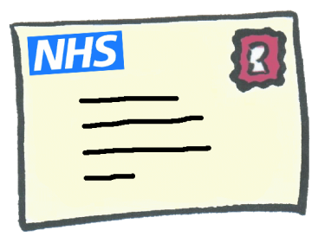 | We are inviting you for cervical screening.  This is also called a smear test.
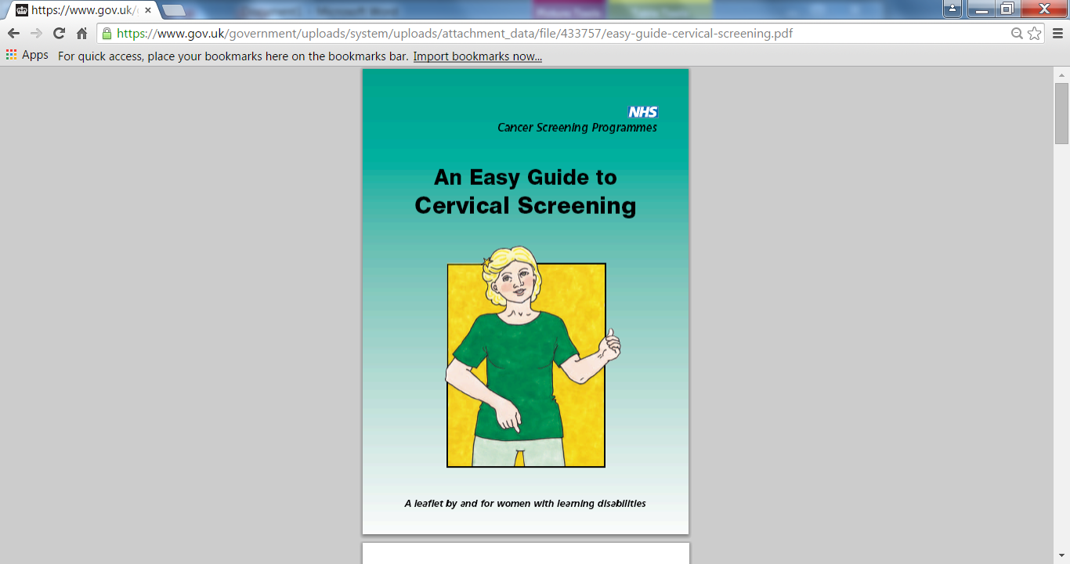  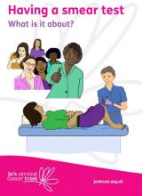 | The leaflet we have sent tells you about cervical screening.  Attach leaflet to letter and delete image as appropriate and below information in red https://www.gov.uk/government/publications/cervical-screening-easy-read-guide  Or  http://www.jostrust.org.uk/resources/materials/information
 | The nurse at the surgery can tell you more about cervical screening.
 | To make an appointment phone Click here to enter text. or come into the surgery.
 | You can bring a friend or carer with you.
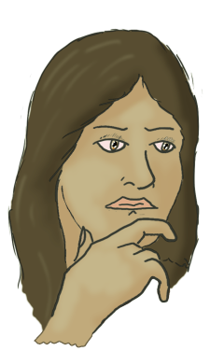 | Confused or worried.  If you need more help to understand cervical screening the learning disability team can help.
 | The community learning disability team can be contacted on Click here to enter text.

Yours sincerely

