Address of screening centre
(font Arial 14)

Date to be inserted (font Arial 14)

Dear
 | Today you attended your bowel scope screening appointment.
 | We were not able to do the test.
 | We think you would benefit from more help to understand the test.
 | Then you can make a choice about whether or not you want to take part in the test.
Your local community learning disability team can help support you.
Their contact details are:

(Contact details of CLDT)
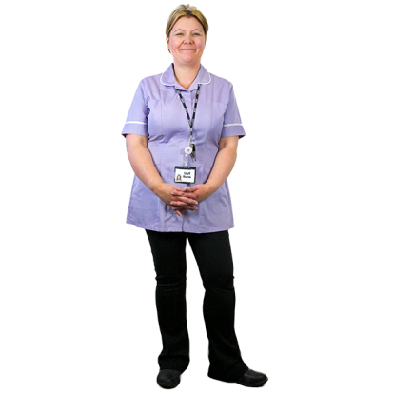 | You can also talk to the bowel screening centre.  Our contact details are:  (contact details and name of SSP)
Bowel scope screening is important.
We want to make sure everybody understands the test and can make a choice about taking part.
 | We will contact the community learning disability team to help you.

Yours faithfully
Signature of lead SSP (Font Arial 14)

