Reference details

Dear ………..
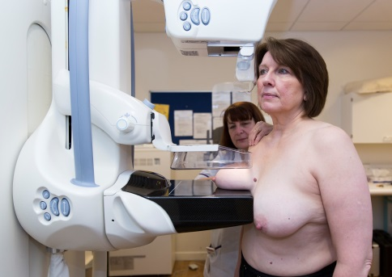 | I understand you did not go to your breast screening appointment. This is called a mammogram.  This is when x-ray pictures are taken of your breasts. The pictures are taken by a woman.
1 in every 8 women will get breast cancer. It is more likely to happen the older you get.

It is easier to treat problems when they are found early so it is important to go for screening. It can help you stay healthy.

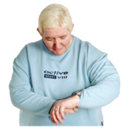  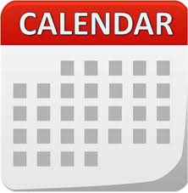 | Another appointment has been made for you  on:  at:
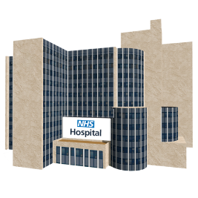 | Please go to:  Picture of Screening Centre or mobile unit if possible or stock image and address
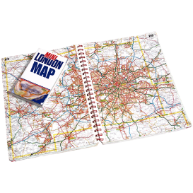 | How to get there:  Map of location, transport details?
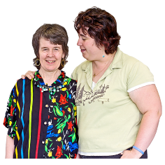 | You can bring someone with you.
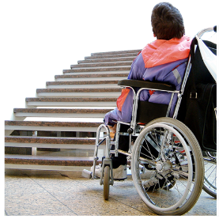 | Please contact us if you do not want your appointment or if you need to change this.  You may also want to tell us about any other needs you have so we can plan for these. For example, if you need more time for your appointment or have a physical disability.  Phone:  Number to call
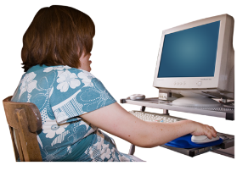  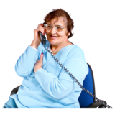 | For more information about breast screening:  • Call the screening centre  • See the information leaflet  • Talk to your doctor or community learning  disability team  • Look online at; www.nhs.uk/conditions/breast-cancer-screening

Yours sincerely

