Reference details

Dear ………..
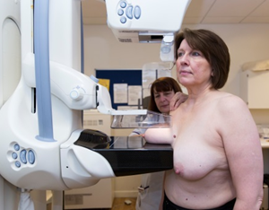 | Thank you for coming for your breast screening appointment. This is called a mammogram.
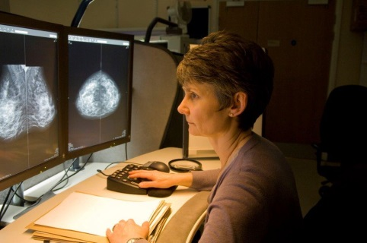 | The pictures were not clear so we have not been able to get a result.  This means we need to take some more pictures of your breasts. These will be taken by a woman.  It is important you attend this appointment to help you stay healthy.
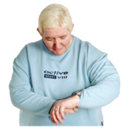  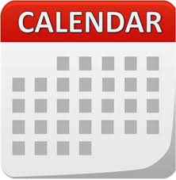 | Another appointment has been made for you  on:  at:
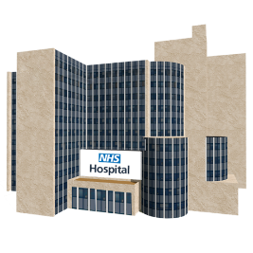 | Please go to:  Picture of Screening Centre or mobile unit or stock image and address
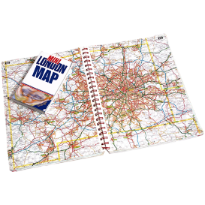 | How to get there:  Map of location, transport details?
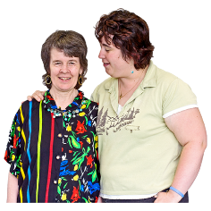 | You can bring someone with you.
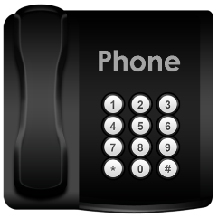  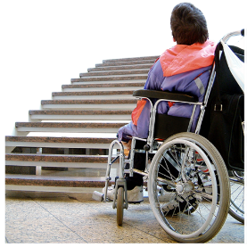 | Please contact us if you do not want your appointment or if you need to change this.  You may also want to tell us about any other needs you have so we can plan for these. For example, if you need more time for your appointment or have a physical disability.  Phone: Number to call
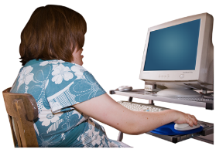  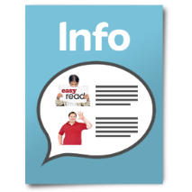  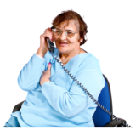 | For more information about breast screening:  • Call the screening centre.  • See the information leaflet  • Talk to your doctor or community learning  disability team  • Look online at ww.nhs.uk/conditions/breast-  cancer-screening

Yours sincerely

